# DECLARATION

This is to certify that this project is an original work and was done by us and it has not been  
submitted elsewhere for the requirement of any degree or diploma or for any other purposes except for publication.

KAKULE KASOLENE Nicolas

Signature ……………………………………………

MUKUBIZA NECIKOKO Regiss

Signature…………………………………………….

# APPROVAL

This is project entitled smart card technology based on access control submitted by  
KAKULE KASOLENE Nicolas, RN: 201620165. And MUKUBIZA NECIKOKO Regiss,  
RN:201620506, to the Department of Computer Science, at KIGALI INDEPENDENT  
UNIVERSITY, is accepted as satisfactory for partial fulfilled of the requirements for the  
Bachelor degree in Computer Science.

DATE  
……………..…………/………./………………  
SIGNATURE

…………………………………………………….  
SUPPERVISOR: Eng. NZAYISENGA HABARUGIRA Marcellin

# DEDICATION

We dedicate this research project to our parents, brothers, sisters, relatives and to everyone who contributed to the success of our project financially, scientifically, and morally.

# ACKNOWLEDGEMENT

Being at the end of our scientific work, we are sincerely thankful to the Almighty God, who filled his grace upon us by giving us the health, the strength and intelligence to reach at the fulfillment of this great work.

We are so grateful to our family members, especially to our parents who have done all their efforts for the success of this work.

We thank our Kigali independent university authorities, all our lecturers, and especially our supervisor, the head of department Eng. NZAYISENGA HABARUGIRA Marcellin, who despite the multitude of responsibilities and works he has, accepted to take of his time to provide us as well as all corrections and contributions for the fulfillment of this project work.

To anyone who contributed in any way to the fulfillment of this work, receive our deepest thanks.

# LIST OF ABBREVIATIONS AND ACCRONYMS

AI : Artificial Intelligent

DBMS : Database Management System  
DFD : Data Flow Diagram  
SDLC : Software Development Life Cycle  
SRC : Software Requirement Specification

GPS : Global positioning System

ICC : Integrated Circuit Card

ISO : International Organization for Standardization

LCD : Liquid Cristal Displayer

OS : Operating System

PTT : Postal and Telecommunications services

RAM : Random Access Memory

RFID : Radio Frequency Interconnection Device

ROM : Read Only Memory

SSADM : Structure Systems Analysis and Design Methodology

# ABSTRACT

This paper handles the build, design and implementation of the access security systems using diverse electronic devices and a desktop application.

Smart Cards are often touted as “secure” portable storage devices. A complete, high-level design methodology has been proposed for embedded information systems based on smart card devices. However, this methodology takes as granted information stored on the card will be really securely stored, and access control will be correctly maintained.

The Smart card technologies are used for the access control in so many applications as financial management, library management, attendance management, inventory management, asset tracking, personnel tracking, controlling access to restricted areas, ID badging, supply chain management, counterfeit prevention (e.g. in the pharmaceutical industries) etc. But in this paper the smart card technologies will be used for securing the campus access at ULK – Gisenyi.

In this paper we try to analyze the existing access control system used at Kigali Independent University ULK, Gisenyi campus. The system of getting access is still being obsolete one is managed in the way that students have cards where their information are written, that allow to the security man to verifier by reading the information printed on the card. In case of visitors, they give their National ID to the security man, this one record some information in a book manually and then when he or she leaves the campus, the ID is given back to him or her. The system is easy to fraud because of it fitness and it is not full secured.

The purpose of this application is to limit the access of the unauthorized person to high security locations, based on access rights of different persons.

In this research work we have used two kinds of methodologies which consist of the data collection methodology called Structure Systems Analysis and Design Methodology (SSADM), and the software development methodology called Software Development Life Cycle (SDLC).

# TABLE OF CONTENTS

[DECLARATION i](#_Toc21517535)

[APPROVAL ii](#_Toc21517536)

[DEDICATION iii](#_Toc21517537)

[ACKNOWLEDGEMENT iv](#_Toc21517538)

[LIST OF ABBREVIATIONS AND ACCRONYMS v](#_Toc21517539)

[ABSTRACT vi](#_Toc21517540)

[TABLE OF CONTENTS vii](#_Toc21517541)

[CHAPTER 1: GENERAL INTRODUCTION 1](#_Toc21517542)

[1.1 BACKGROUND 1](#_Toc21517543)

[1.2 PROBLEM STATEMENT 5](#_Toc21517544)

[1.3 HYPOTHESIS 5](#_Toc21517545)

[1.4. SCOPE OF THE STUDY 5](#_Toc21517546)

[1.4.1. Scope in time 6](#_Toc21517547)

[1.4.2. Scope in domain 6](#_Toc21517548)

[1.4.3 Scope in space 6](#_Toc21517549)

[1.5 METHODOLOGICAL APPROACH 6](#_Toc21517550)

[1.5.1 Methodology 6](#_Toc21517551)

[1.5.2 Techniques 7](#_Toc21517552)

[1.6 PROJECT GANTT CHART 12](#_Toc21517553)

[1.7 ORGANIZATION OF THE PROJECT 12](#_Toc21517554)

[CHAPTER 2: LITERATURE REVIEW 13](#_Toc21517555)

[2.1. DEFINITION OF KEY CONCEPTS 13](#_Toc21517556)

[Basic Components of Access Control Systems 13](#_Toc21517557)

[User facing 13](#_Toc21517558)

[How smart cards work 14](#_Toc21517559)

[Types of smart cards 14](#_Toc21517560)

[1.1. Software development tools 17](#_Toc21517561)

[CHAPTER 3: SYSTEM ANALYSIS AND DESIGN 19](#_Toc21517562)

[3.1. Introduction 19](#_Toc21517563)

[3.2. Problem with the Current System 19](#_Toc21517564)

[3.3. Proposed system 20](#_Toc21517565)

[3.4. Methodological approach 20](#_Toc21517566)

[3.4.1. Data collection techniques 20](#_Toc21517567)

[3.4.2. Software Development Process Model 21](#_Toc21517568)

[3.5. System Requirements 21](#_Toc21517569)

[3.5.1. Functional requirements 21](#_Toc21517570)

[3.5.2. Non-functional Requirement 22](#_Toc21517571)

[3.6. Function diagram 23](#_Toc21517572)

[3.6.1. Use case diagram 23](#_Toc21517573)

[3.6.2. Class diagram 24](#_Toc21517574)

[3.6.3. Sequence diagram 25](#_Toc21517575)

[3.7 Data Dictionary (DD) 26](#_Toc21517576)

[CHAPTER 4: SYSTEM IMPLEMENTATION 28](#_Toc21517577)

[CHAPTER 5. CONCLUSION AND RECOMMANDATION 53](#_Toc21517578)

[5.1. Conclusion 53](#_Toc21517579)

[5.2. Recommandation 53](#_Toc21517580)

[5.3. FUTURE WORK 54](#_Toc21517581)

[REFERENCES 55](#_Toc21517582)

# TABLE OF FIGURES

[Figure 1. System Development Life Cycle (SDLC) 8](#_Toc21521217)

[Figure 2. Waterfall model 10](#_Toc21521218)

[Figure 3.Gantt chart for the project 12](#_Toc21521219)

[Figure 4. Contactless smart card 15](#_Toc21521220)

[Figure 5.Access Control System Use case Diagram 23](#_Toc21521221)

[Figure 6. Class diagram 24](#_Toc21521222)

[Figure 7. Sequence diagram 25](#_Toc21521223)

[Figure 8. Working principle diagram 28](#_Toc21521224)

[Figure 9. Arduino Nano 29](#_Toc21521225)

[Figure 10. Radio-frequency Identification 30](#_Toc21521226)

[Figure 11. Tags (Smart Card) 30](#_Toc21521227)

[Figure 12. LCD 31](#_Toc21521228)

[Figure 13. LED 31](#_Toc21521229)

[Figure 14. Login interface of the information system 32](#_Toc21521230)

[Figure 15.Admin Home Page Interface 33](#_Toc21521231)

[Figure 16. Admin - Add New User Page / User 34](#_Toc21521232)

[Figure 17.Admin - Add New Student Page / Student 35](#_Toc21521233)

[Figure 18. Admin - View Enrollments Page / All Users 36](#_Toc21521234)

[Figure 19. Admin - View Enrollments Page / All Students 37](#_Toc21521235)

[Figure 20. Admin – Update Records Page / User 38](#_Toc21521236)

[Figure 21. Admin – Update Records Page / Student 39](#_Toc21521237)

[Figure 22. Admin – Edit Profile 40](#_Toc21521238)

[Figure 23. Admin – Logout 41](#_Toc21521239)

[Figure 24. User Home Page Interface 42](#_Toc21521240)

[Figure 25. User - Entry Page / Students 43](#_Toc21521241)

[Figure 26. User - Entry Page / Visitors 44](#_Toc21521242)

[Figure 27. User - Exit Page / Students 45](#_Toc21521243)

[Figure 28. User - Exit Page / Visitors 46](#_Toc21521244)

[Figure 29. User - View / Print Page / Students 47](#_Toc21521245)

[Figure 30.User - View / Print Page / Visitors 48](#_Toc21521246)

[Figure 31.User – Edit Profile 49](#_Toc21521247)

[Figure 32. Admin – Logout 50](#_Toc21521248)

[Figure 33. Admin / User Change Password 51](#_Toc21521249)

# CHAPTER 1: GENERAL INTRODUCTION

## **1.1 BACKGROUND**

It has been said that smartcards will one day be as important as computers are today. This statement contains a bit of an error because it implies that smartcards are not computers, when in fact, they are. In this chapter we will describe the history of smartcards, some different types, their low-level properties, the standards that affect their adoption in mainstream society, and how they relate to today’s computer security systems.

Because smartcards are indeed tiny computers, it’s difficult to predict the variety of applications that will be possible with them in the future. It’s quite possible that smartcards will follow the same trend of rapid increases in processing power that computers have, following "Moore’s Law" and doubling in performance while halving in cost every eighteen months.

Smartcards have proven to be quite useful as a transaction/authorization/identification medium in European countries. As their capabilities grow, they could become the ultimate thin client, eventually replacing all of the things we carry around in our wallets, including credit cards, licenses, cash, and even family photographs. (The photographs could be viewed and/or exchanged by capable terminals or personal computers.) By containing various identification certificates, smartcards could be used to voluntarily identify attributes of ourselves no matter where we are or to which computer network we are attached.

We won't try to predict the future of smartcard application possibilities, nor their impact on society, but instead we focus on the state of the art for smartcards and their use in computer and network security systems. It is not scientifically comprehensive regarding every detail of integrated circuit cards, but instead tries to strike a balance between accuracy and comprehensibility. The standards and references that are mentioned throughout the chapter can be used to find more specific information.

Technology has become so powerful compared to the older world without technology that made up this to develop some factors. It came to shift the manual system that was used by an automated system which allows every-one to be independent and selfish to some factors of the life. Indeed, the automated system does pass some stats that can’t be done by human through robot’s development and others which are using AI.

For this scanner of card is more important step forward due to not only electronic sensors, and powerful microcontrollers developed progress but also due to the fact it is more developed in access security of door and others factors which will permit for other an authorized access or an access denied, this is compared to robot by its potential and its capacity to manage data by itself and provide an output according to data inside without any human help. The information get will be kept into a database through the desktop software build to manage data.

Distinct devices will be used for making this prototype complex, it is a multitask though its capacity of doing many tasks at a time by different devices used like sensors, to get information read form the card we will using a RFID which is able to read information for a certain distance eg: 6 ich. This device contains Radio Frequencies which allow the capacity of scanning a card and read or write data inside it. We must say that the base of the door security is a scanner

This device will be used into many things like project, enterprises, organizations and others because of in specification of security to manage each entry and exit of employees or students in our case study or other information for the visitors and know information of each one.

These characteristics make smartphones and computers more important and very attractive to this project; the targeted platform for our application will be desktop application because it is the more used and more familiar system in the world.

VISA and MasterCard then entered the market, but eventually the cost pressures of fraud, tampering, merchant handling, and bank charges made a machine-readable card necessary. The magnetic stripe was introduced, and this allowed further digitized data to be stored on the cards in a machine-readable format. This type of embossed card with a magnetic stripe is still the most commonly used method of payment. Magnetic stripe technology suffers from a critical weakness, however, in that anyone with access to the appropriate device can read, re-write, or delete the data. Thus a mag-stripe card is unsuitable for storing sensitive data and, as such, requires an extensive on-line, centralized, back-end infrastructure for verification and processing.

In 1968, German inventors Jürgen Dethloff and Helmut Grötrupp applied for the first ICC related patents. Similar applications followed in Japan in 1970 and France in 1974. In 1984, the French PTT (Postal and Telecommunications services) successfully carried out a field trial with telephone cards. By 1986, many millions of French telephone smartcards were in circulation. Their number reached nearly 60 million in 1990, and 150 million are projected for 1996.

As cryptography made great progress in the 1960s and security mechanisms could be proved mathematically, smartcards proved to be an ideal medium for safely storing cryptographic keys and algorithms. French banks were the first field this type of a card by introducing a chip-incorporating bank card in 1984. German banks began introducing them around 1997. Another application fielded in Germany included over 70 million smartcards issued which carried health insurance information.

**Types of Cards**

The International Organization for Standardization (ISO) standard 7810 "Identification Cards – Physical Characteristics" defines physical properties such as flexibility, temperature resistance, and dimensions for three different card formats (ID-1, ID-2, and ID-3). The Smart Card standard, ISO 7816, is based on the ID-1 format. In order to give perspective, several different types of ID-1 cards will be described in this section. One type in particular, namely cryptographic coprocessor cards, are becoming very important to current computer and network security systems.

Embossed Embossing allows for textual information or designs on the card to be transferred to paper by using a simple and inexpensive device. ISO 7811 specifies the embossed marks, covering their form, size, embossing height, and positioning. Transfer of information via embossing may seem primitive, but the simplicity of the system has made worldwide proliferation possible.

Magnetic Stripe The primary advantage that magnetic stripe technology offers over embossing is a reduction in the flood of paper documents. Parts 2, 4, and 5 of ISO 7811 specify the properties of the magnetic stripe, coding techniques, and positioning. The stripe’s storage capacity is about 1000 bits and anyone with the appropriate read/write device can view or alter the data.

Smartcards the Following Integrated Circuit Cards have conventionally come to be known as "Smartcards". These are the newest and cleverest additions to the ID-1 family, and they also follow the details laid down in the ISO 7816 series. These types of cards allow far greater orders of magnitude in terms of data storage – cards with over 20 Kbytes of memory are currently available. Also, and perhaps most important, the stored data can be protected against unauthorized access and tampering. Memory functions such as reading, writing, and erasing can be linked to specific conditions, controlled by both hardware and software. Another advantage of smartcards over magnetic stripe cards is that they are more reliable and have longer expected lifetimes.

Memory Cards Though referred to as smartcards, memory cards are typically much less expensive and much less functional than microprocessor cards. They contain EEPROM and ROM memory, as well as some address and security logic. In the simplest designs, logic exists to prevent writing and erasing of the data. More complex designs allow for memory read access to be restricted. Typical memory card applications are pre-paid telephone cards and health insurance cards.

Microprocessor Cards Components of this type of architecture include a CPU, RAM, ROM, and EEPROM. The operating system is typically stored in ROM, the CPU uses RAM as its working memory, and most of the data is stored in EEPROM. A rule of thumb for smartcard silicon is that RAM requires four times as much space as EEPROM, which in turn requires four times as much space as ROM. Typical conventional smartcard architectures have properties reflected in Table 17-1.

## **1.2 PROBLEM STATEMENT**

A problem statement is a concise description of an issue to be addressed or a condition to be  
improved upon. The first condition of solving a problem understands the problem, which  
can be done by way of a problem statement.

In the current system we have some problems that the access at ULK Gisenyi – Campus is given to the unauthorized person because the system in use is not sophisticate compared to othertechnologies found earlier. Basing on the current system, some of the main problems are:

* Students can access the campus with the wrong student card;
* For the security purpose, entries and exits of students and visitors are not managed.

From the problems stated above, two questions can be formulated in this way:

* Which technology can be used to give access to the right person?
* How students’ and visitors’ entries and exits can be managed?

## **1.3 HYPOTHESIS**

A hypothesis is a supposition or proposed explanation made on basis of limited evidence as a starting point for further investigation; it is an educated prediction that can be tested (Alina, 2017).

* The Smart cards with a unique ID will be used as a student card to ensure the secured access into the campus;
* The RFID Card Reader will be used to read the unique ID of the smart card;
* The Desktop Application will be used to record students and visitors information in the database; and to manage the entries and exits.

## **1.4. SCOPE OF THE STUDY**

In order to conduct a scientific research, a researcher must have a precise and clear delimitation study; therefore, in the next paragraph we are going to scope our project in space, in time and in domain.

### 1.4.1. Scope in time

This project is built in 2019 with the purpose of solving the problem of access control management.

### 1.4.2. Scope in domain

As we specified here behind that this project is built with the purpose of solving the problem of access control management at ULK Gisenyi Campus. So, the system will do the following:

* Register the user of the system and the students in the database in the Desktop application;
* Attribute the identity of users and students to a give smart card with an individual ID;
* Manage the entries and exits of students in the campus;
* Records the visitors information and manage their entries and exits.

This system is not designed to:

* To manage the student’s financial data;
* To manage the students attendance.

### 1.4.3 Scope in space

Our study which speaks about the smart card technology based on access control at ULK GISENYI CAMPUS, located in Gisenyi Sector Rubavu, Western Province in Rwanda Country.

## **1.5 METHODOLOGICAL APPROACH**

To complete such scientific work is not hazardous. It results from the research methodology and the chosen techniques.

1.5.1 Methodology  
 In research methodology we have two kinds of methodology:

1. **Data collection methodology**

During the development of this project we use the “Structure Systems Analysis and Design  
Methodology (SSADM)” which is a system approach to analyze and design of the information.

1.5.2 Techniques  
In order to collect data, we have used interview, observation and documentation.

* **Techniques of interview**

The interview technique consists to organise a conversation in which the investigator asks questions to the surveyed person in order to gather information on the hypotheses and concepts indicators.

Albert BRIMO, quoted by N.MULAMBATI. (1980:28) defined interview as: “*A technique that aims at organizing a report of oral communication between two people: the interviewer and the interviewee in order to allow the investigation to collect some information about a precise subject”.*

As this technique is based on the communication between the interviewer and the interviewee, we have used it to allow us to ask many questions regarding to our study to different students.

* **Technique of documentation**

In order to conduct our research, documentation technique has been used for consulting a wide variety of documents such as different books in the library, website to read some online courses.

* **Techniques of observation**

According to N.MULUMBATI (1980:26): “observation is the most important, technique used by researchers to collect data. Nothing can replace a researcher’s direct contact with his domain and no other technique can enable a researcher in gathering more idea than observation technique”.

This technique of research concerns the planned watching, recording and analysis of observed behavior as it occurs in a natural setting in observing, we have been able to understand the functionality of the earlier system.

1. **Software developmentmethodology**

In this step, we are going to use a SDLC which is the process used by the software industry to design, develop and test high quality software. The SDLC aims to produce high quality software that meets or exceeds customer expectations, reaches completion within times and cost estimates.

The following figure is a graphical representation of the various stages of a typical SDLC.

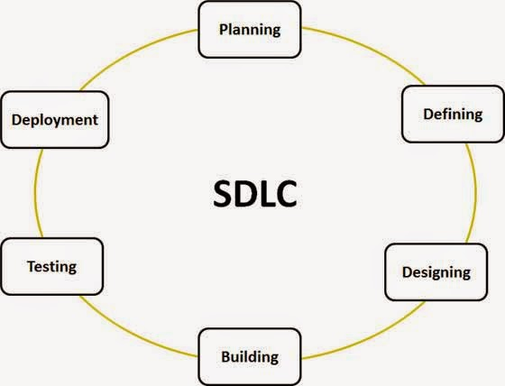

**Figure 1. System Development Life Cycle (SDLC)**

*Source: From Tutorialspoint.com*

***Stage 1: Planning and Requirement Analysis***

Requirement analysis is the most important and fundamental stage in SDLC it’s performed by the senior members of the team with inputs from the customer, the sales department, market surveys and domain experts in the industry. The planning for the quality assurance requirements and identification of the risks associated with the project is also done in the planning stage.

***Stage 2: Defining Requirements***

Once the requirement analysis is done the next step is to clearly define and document the product requirements and get them approved from the customer or the market analysis. This is done through an SRS (Software Requirement Specification) document which consists of all the product requirements to be designed and developed during the project life cycle.

***Stage 3: Designing the product Architecture***

SRC is the reference for product architects to come out with the best architecture for the product to be developed.

***Stage 4: Building or developing the product***

In this stage of SDLC the actual development starts and the product is built. The developers must follow the coding guidelines defined by their organization and programming tools like compilers, interpreters, debuggers, etc. are used to generate the code.

***Stage 5: Testing the product***

This stage is usually a subset of all the stages as in the modern SDLC models, the testing activities are mostly involved in all the stages of SDLC.

***Stage 6: Deployment in the Market and Maintenance***

Once the product is tested and ready to be deployed it is released formally in the appropriate market

**CHOICE OF THE SDLC MODELS**

There are various software development life cycle models defined and designed which are followed during the software development process but among them we have chosen to use the waterfall model for this project.

**1.5.3 *Waterfall model***

Waterfall approach was the first SDLC model to be used widely in software engineering to ensure success of the project. In this model approach, the whole process of software development is decided into separate phases and the outcome of one phase acts as the input for the next phase sequentially.

*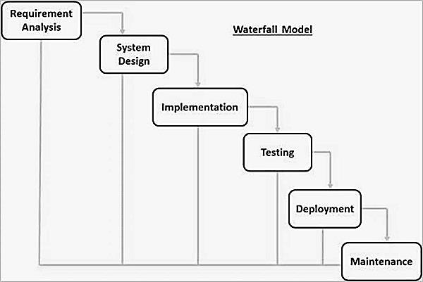*

**Figure 2. Waterfall model**

*Source: From Tutorialspoint.com*

*The sequential phases in Waterfall model are:*

* ***Requirement Gathering and analysis***: All possible requirements of the system to be developed are captured in this phase and documented in a requirement specification document;
* ***System Design***: The requirement specifications from first phase are studied in this phase  
  and the system design is prepared. This system design helps in specifying hardware and  
  system requirements and helps in defining the overall system architecture;
* ***Implementation***: With inputs from the system design, the system is first developed in  
  small programs called units, which are integrated in the next phase. Each unit is developed and tested for its functionality, which is referred to as Unit Testing;
* ***Integration and Testing***: All the units developed in the implementation phase are integrated into a system after testing of each unit. Post integration the entire system is tested for any faults and failures;
* ***Deployment of system***: Once the functional and non-functional testing is done; the  
  product is deployed in the customer environment or released into the market;
* ***Maintenance***: There are some issues which come up in the client environment. To fix those issues, patches are released. Also, to enhance the product some better versions are released. Maintenance is done to deliver these changes in the customer environment.

**Waterfall model advantages**

* Simple and easy to understand and use;
* Easy to manage due to the rigidity of the model. Each phase has specific deliverables and a review process;
* Phases are processed and completed one at a time;
* Works well for smaller projects where requirements are very well understood;
* Clearly defined stages;
* Wellunderstoodmilestones;
* Easy to arrange tasks;
* Process and results are well documented.

## **1.6 PROJECT GANTT CHART**

|  |  |  |  |  |  |  |  |  |  |  |  |  |
| --- | --- | --- | --- | --- | --- | --- | --- | --- | --- | --- | --- | --- |
| N0 | Task | Start | End | Year 2019 | | | | | | | | |
| Jan | Feb | Mar | April | May | Jun | July | Aug | Sept |
| 01 | System feasibility | 12/Jan | 26/Jan |  |  |  |  |  |  |  |  |  |
| 02 | Requirements analysis and project planning | 27/Jan | 05/Feb |  |  |  |  |  |  |  |  |  |
| 03 | System design | 07/Feb | 18/Ap |  |  |  |  |  |  |  |  |  |
| 04 | System development | 22/Ap | 27/Jul |  |  |  |  |  |  |  |  |  |
| 05 | System Test | 29/Jul | 24/Aug |  |  |  |  |  |  |  |  |  |
| 06 | System Implementation | 1/Sept | 13/Spt |  |  |  |  |  |  |  |  |  |

**Figure 3.Gantt chart for the project**

***Source****: Own drawing*

## **1.7 ORGANIZATION OF THE PROJECT**

This project contains five chapters:

* ***Chapter 1****: The General introduction*: This chapter is concerned with problem statement, problem scope and project purpose;
* ***Chapter 2****: Literature Review*: This chapter deals with the theoretical concepts it means it provides a description, summary and evaluation of each source;
* ***Chapter 3****: System analysis and design*: In this chapter we analyze the current system, the new one then put in place the methodology to be used, tools and the system requirements;
* ***Chapter 4****: System implementation:* In this chapter we will proceed by showing exactly how the system will work, in other words, we will:
  + Show how the information system should be built (i.e. physical system design).
  + Ensure that the information system is operational and used.
  + Ensure that the information system meets quality standard (i.e. quality assurance).
* ***Chapter 5****: Conclusion and recommendations:* in this chapter we provide the general conclusion.

# CHAPTER 2: LITERATURE REVIEW

For universities where security is primordial, getting access must be checked, an access control system should be used in order to enhance security in general and to reduce time-consuming in access control of an important number of candidates in the same time. To insure the access control; Smart cards, card reader and software application technologies are used in this system. Smartcard offers the unique Id number, Card reader guarantees a simultaneous reading of the identified objects and the software application offers a storage capacity and enables processing information. Several problems of security remain still unresolved for smartcard, card reader and software application used separately. We present in this paper a solution of access control, which combines specific identification and authentication technologies with synchronous and asynchronous data processing. In our case, we target the academic context. We demonstrate by one use case how much the system security could be improved by combining RFID and Smartcards in a complementary way. For this purpose, the design of our system focuses in the first scenario on performing the verification of the student’s valid smart card by using both synchronous and asynchronous techniques based on the coupling of RFID and smart card technologies. The second scenario focuses on the security of accessing the campus by visitor’s verification’ method requiring immediate validation of the access based on Desktop Software. Further technologies are also used to ensure accurate authentication, such as cameras.

## **2.1. DEFINITION OF KEY CONCEPTS**

### Basic Components of Access Control Systems

Access control systems vary widely in types and levels of complexity; however, most card access control systems consist of at least three basic components:

### User facing

Smart cards, card reader and software application

* + 1. **Smart Card**

A smart card is a physical card that has an [embedded](https://internetofthingsagenda.techtarget.com/definition/embedded-system) integrated chip that acts as a security token. Smart cards are typically the same size as a driver's license or credit card and can be made out of metal or plastic. They connect to a reader either by direct physical contact (also known as [chip and dip](https://whatis.techtarget.com/definition/card-dipping-EMV-card-dipping)) or through a short-range wireless connectivity standard such as radio-frequency identification ([RFID](https://internetofthingsagenda.techtarget.com/definition/RFID-radio-frequency-identification)) or near-field communication ([NFC](https://searchmobilecomputing.techtarget.com/definition/Near-Field-Communication)).

### How smart cards work

Smart card microprocessors or memory chips exchange data with card readers and other systems over a serial interface. The smart card itself is powered by an external source, usually the smart card reader. A smart card communicates with readers either via direct physical contact or using a short-range wireless connectivity standard such as RFID or NFC. The card reader then passes data from the smart card to its intended destination, usually a payment or authentication system connected to the smart card reader over a network connection.

### Types of smart cards

Smart cards can be categorized on different criteria including by how the card reads and writes data, by the type of chip implanted in the card and by the capabilities of that chip. Some of the different of types of smart cards include:

* **Contact smart cards** are the most common type of smart card. Contact smart cards are inserted into a smart card reader that has a direct connection to a conductive contact plate on the surface of the card
* **Contactless smart cards** require only close proximity to a card reader to be read; no direct contact is necessary for the card to function. The card and the reader are both equipped with antennae and communicate using radio frequencies over the contactless link. A contactless smart card functions by being put near the reader to be read. (S Goldthwaite, W Graylin, 2004).
* **Dual-interface cards** are equipped with both contactless and contact interfaces. This type of card enables secure access to the smart card's chip with either the contactless or contact smart card interfaces.
* **Hybrid smart cards** contain more than one smart card technology. For example, a hybrid smart card might have one embedded processor chip that is accessed through a contact reader as well as an RFID-enabled chip used for proximity connection.
* **Memory smart cards** contain memory chips only and can only store, read and write data to the chip; the data on memory smart cards can be over-written or modified, but the card itself is not programmable so data can't be processed or modified programmatically.
* **Microprocessor smart cards** have a microprocessor embedded onto the chip in addition to memory blocks. A microprocessor card may also incorporate specific sections of files where each file is associated with a specific function.

Smart cards can also be categorized by their application, such as credit card, debit card, entitlement or other payment card, authentication token and so on. ([**Margaret Rousse**](https://www.techtarget.com/contributor/Margaret-Rouse))

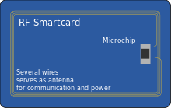**Contactless smart cards.**

**Figure 4. Contactless smart card**

**Source**: [businessinsider](https://www.businessinsider.com/)

* + 1. **Arduino**

Arduino is an open-source electronics prototyping platform based on flexible, easy-to-use hardware and software. It’s intended for artists, designers, hobbyists, and anyone interested in creating interactive objects or environments.(Bruce 2011)

The most used boards the Arduino family are:

* Arduino Uno is the basic one with a replaceable chipset and the most used
* Arduino Mega, 2560, it provides more input and outputs than others
* Arduino Nano, is a small, complete, and breadboard-friendly board based on the ATmega328P (**Arduino Nano** 3.x)
* Arduino LilyPad, is wearable as clothes
  + 1. **RFID Card Reader**

**What is an RFID reader?**

RFID is an acronym for “radio-frequency identification” and refers to a technology whereby digital data encoded in RFID tags or smart labels (defined below) are captured by a reader via radio waves. RFID is similar to barcoding in that data from a tag or label are captured by a device that stores the data in a database. RFID, however, has several advantages over systems that use barcode asset tracking software. The most notable is that RFID tag data can be read outside the line-of-sight, whereas barcodes must be aligned with an optical scanner. If you are considering implementing an [RFID solution](https://www.abr.com/solutions/rfid/), take the next step and contact the RFID experts at AB&R® (American Barcode and RFID 2004).

In simple words an RFID uses electromagnetic fields to transfer data over short distances. RFID is useful to identify people, to make transactions, Inventory management, Asset tracking, Personnel tracking, Controlling access to restricted areas, ID Badging, Supply chain management, Counterfeit prevention (e.g. in the pharmaceutical industry), etc…

You can use an RFID system to open a door. For example, only the person with the right information on his card is allowed to enter. An RFID system uses:

**>> Tags**attached to the object to be identified, in this example we have a keychain and an electromagnetic card. Each tag has hisown identification (UID).

* + 1. **Software Application**

Application software is a program or group of programs designed for end users. These programs are divided into two classes: system software and application software. While system software consists of low-level programs that interact with computers at a basic level, application software resides above system software and includes applications such as database programs, word processors and spreadsheets. Application software may be bundled with system software or published alone.

***Source****:* [*Techopedia*](https://www.techopedia.com/definition/4224/application-software)

* + - 1. ***Desktop application***

An application that runs stand-alone in a desktop or laptop computer. Contrast with "Web-based application," which requires the Web browser to run. The term may be used to contrast desktop applications with mobile applications that run in smart phones and tablets.

***Source***:*pcmag*

## **Software developmenttools**

* + 1. **The waterfall model**

The waterfall model is a model developed for software development. It consists of developing software by systematically going from the first to the last phase of software development before producing the software.

The most important phases of software development are:

* Requirements
* Design
* Implementation
* Verification
* Maintenance
  + 1. **System analysis and design method**

For this dissertation the object oriented System analysis and design (OOSAD) method has been preferred. It has been used since mid/late 1980 to date. It describes the real world by it object, the attributes, services and relationship. The main purpose of this method is to identify the object and their relationship to be designed.

* + 1. **Tools and languages used in implementation**

1. **C sharp**

C# (pronounced "C-sharp") is an [object-oriented programming](https://searchmicroservices.techtarget.com/definition/object-oriented-programming-OOP) language from Microsoft that aims to combine the computing power of [C++](https://searchsqlserver.techtarget.com/definition/C) with the programming ease of [Visual Basic](https://searchwindevelopment.techtarget.com/definition/Visual-Basic). C# is based on C++ and contains features similar to those of [Java](https://www.theserverside.com/definition/Java).

1. **Arduino**

Arduino is an open source electronic platform based on an easy hardware and software intended to anyone who want to work on interactive projects.

It has a wide range of electronic microcontroller and a programming environment and language based on C++ programming language.

1. **Visual Studio community**

Microsoft Visual Studio community is an Integrated Development Environment (IDE) and a freeware version of Visual Studio. This package can be considered as a learning IDE for students, hobbyists and newcomers to Visual Studio programming.

# CHAPTER 3: SYSTEM ANALYSIS AND DESIGN

## **Introduction**

In this chapter, not only the design and structure of the access control system will be mentioned but also the current system working principle and the proposed system working principle will be compared.

Before the design of the new system, we first have to examine the existing one in order to identify the problems and determine functionalities for us to develop an appropriate system that provides acceptable and useful solutions concerning the campus access control using RFID Reader and Desktop application.

## **Problem with the Current System**

* + 1. **Introduction**

At Kigali Independent University ULK , Gisenyi campus, the system of getting access is still being obsolete one is managed in the way that students have cards where their information are written, that allow to the security man to verifier by reading the information printed to the card and it takes time to read to avoid fraud. In case of visitors, they give their National ID to the security man, this one record some information in a book manually and then when he or she leaves the campus, the ID is given back to him or her. The system is easy to fraud because of it fitness and it is not full secured.

* + 1. **Problem with the Existing system**

After analyzing the existing access control system used at ULK Gisenyi campus which is based on normal printed card and paper based for visitors, we have realized that the system has some problems and lacks. With the normal printed student card, access can be given to an unauthorized student that is using a wrong copy of student card, because there is no way to verifier if the student really exists in the database. This system is using also the paper based when recording information of visitors, which is not trustable because the register book can be lost and it is a time consuming.

## **Proposedsystem**

* + 1. **Introduction**

In order to overcome the limitation and problems of the current system, this dissertation proposed to develop desktop based application and student smart card to optimize the access control of the Campus.

In the proposed system, the RFID through its radio frequency sensors using radio waves will identify the ID of the Smart Card, sends the ID into the Desktop Application that will verify if there is a student with a card of that ID in the database and send back the information to the RFID Reader that will finally display the message of accepting or denying on the LCD Screen if access is authorized or unauthorized, each Card should content is own ID different to users.

To manage the visitor access, in the proposed system, the visitor will give his or her identity card to user of the system, this one will recorder information using the desktop application, and an USB Camera to record the picture of the visitor, other optional information will be added automatically according to the system to avoid fraud like time of entering and exiting the campus for the security issue. Therefore visitor should left his ID to the guard’s gate when is try to get access into the campus and when he leaves the card will be rendered to him.

## **Methodologicalapproach**

Methodology is a formal development process that defines a set of activities, methods, practices, deliverables and automated tools that are used by developers and projects managers to implement and maintain information systems.

### Data collection techniques

To understand deeply the requirement and the problem domain, some techniques will help to achieve the aim of this dissertation. The three main techniques used are “Documentation”, “interview” and “observation”.

* ***Documentation technique***

This technique allows the researcher to consult books, memories, class notes and search some documents on internet that are related to his work.

* ***Interview***

In this research the interview technique has been used as data collection technique, it consisted of the conversation between the researcher and the person holding some key information.

* ***Observation***

Observation is a systematic data collection approach.  Researchers use all of their senses to examine people in natural settings or naturally occurring situations.

### Software DevelopmentProcess Model

The development models are the various processes or methodologies that are being selected for the development of the project depending on the project’s name objectives. Many development life cycle have been developed to allow people to reach different objectives. In this dissertation, the waterfall model has been preferred.

## **System Requirements**

The system requirement includes functional requirement and non-functional requirement. The functional requirement is composed by what the system is intended to do while the non-functional requirement indicates how the system must be (Julius guzer, 2015).

### Functionalrequirements

A functional requirement in software engineering defines a function of a software system or its component. A function is described by a set of inputs, behavior and outputs. They may be calculations, technical details, data manipulation and processing and other specific functionalities that define what a system is supposed to accomplish.

* **RFID Reader / Writercontroller**

1. The RFID controller shall receive and send data through radio transceiver;
2. The RFID controller system shall read sensor data;
3. The RFID system shall monitor the access control status through LCD screen;
4. The RFID system shall display the status light color through LEDs;
5. The RFID shall control the BUZZER.

* **Desktop application**

1. The application shall send and receive data from RFID through a USB;
2. The application shall register users and students;
3. The application shall update user and student’s information;
4. The application shall record visitor’s information;
5. The application shall verify if the user or student exist in the database.

### Non-functionalRequirement

Non-functional requirements are often called qualities of a system. Other terms for non-functional requirements are “**constraints”**, “**quality attributes”, and “quality goals”, “quality of service requirements.**

Non-functionalrequirement description:

* **Reliability Issues**

The system shall be completely operational 24/24 hours;

Down time after a failure shall not exceed 30 sec.

* **Usability Issues**

The system should work without any interruption, data should arrive on time respecting their integrity in order to allow the system and the operator to take good decisions.

* **Performance**

The system speed and accuracy processing accuracy should be high so that the user’s request will be handled rapidly.

* **Flexibility**

The system should be easy to adapt and integrate in others companies.

* **Availability**

The system should be available at any time and in any kind of environment except when working conditions are not respected.

## **Functiondiagram**

### Use case diagram

A use case diagram can summarize the details of your system's users (also known as actors) and their interactions with the system. It is used to identify, clarify and organize system requirements.

They are usually referred to as behavior diagrams used to describe a set of action (use cases) that some system or systems (subject) should or can perform in collaboration with one or more external users of the system (actors). Each use case should provide some observable and valuable result to the actors or other stakeholders of the system.

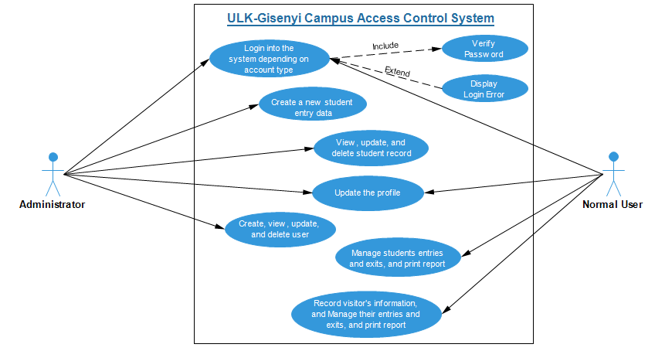

**Figure 5.Access Control System Use case Diagram**

***Source****: Own drawing using Edraw Max*

### Class diagram

A **class diagram** is an illustration of the relationships and source code dependencies among **classes** in the Unified Modeling Language (UML). In this context, a **class** defines the methods and variables in an object, which is a specific entity in a program or the unit of code representing that entity (*SK Kim, C David, 1999*).

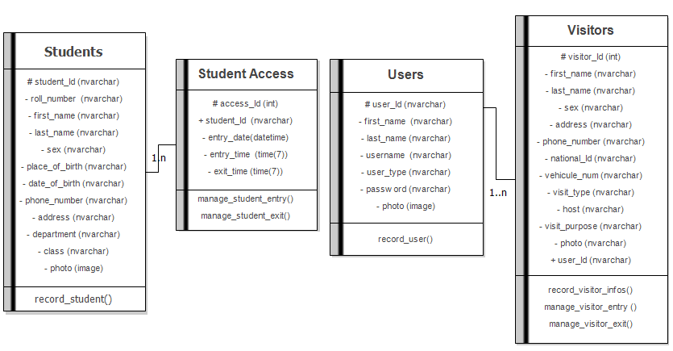

**Figure 6. Class diagram**

***Source****: Own drawing using Edraw Max*

### Sequencediagram

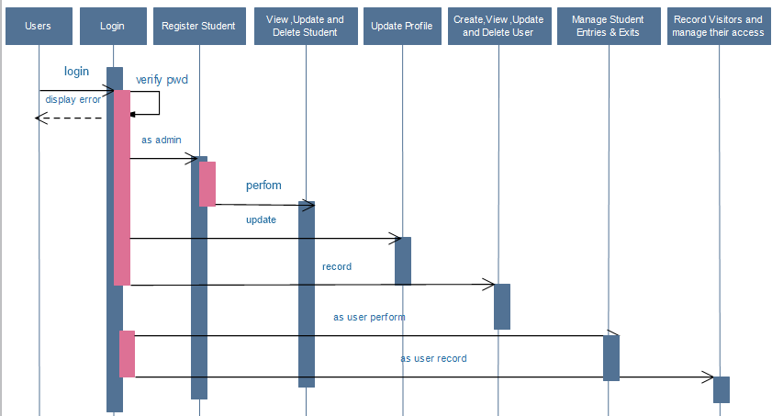A **sequence diagram** shows object interactions arranged in time **sequence**. It depicts the objects and classes involved in the scenario and the **sequence** of messages exchanged between the objects needed to carry out the functionality of the scenario.

**Figure 7. Sequence diagram**

***Source****: Own source using Edraw Max*

## 

## **Data Dictionary****(DD)**

|  |  |  |  |  |
| --- | --- | --- | --- | --- |
| **TABLE** | **COLUMN** | **TYPE** | **CONSTRAINT** | **DESCRIPTION** |
| **USERS** | Id | nvarhar (30) | Primary Key | The unique identifier of the user |
| User\_name | nvarhar (30) | Not Null | The user name of the user |
| Password | nvarhar (20) | Not Null | The password of the user |
| **STUDENTS** | Id | nvarhar (30) | Primary Key | The unique identifier of the student |
| Roll\_number | nvarhar (9) | Not Null | The roll number of the student |
| First\_name | nvarhar (30) | Null | The first name of the student |
| Last\_name | nvarhar (30) | Null | The last name of the student |
| Sex | nvarhar (15) | Null | The gender of the student, either male or female |
| Place\_of\_birth | nvarhar (30) | Null | The place of birth of the student |
| Date\_of\_birth | nvarhar (50) | Not Null | The date of birth of the student |
| Phone\_number | nvarhar (20) | Null | The phone number of student |
| Address | nvarhar (50) | Null | The address of the student |
| Department | nvarhar (50) | Not Null | The department of the student |
| Class | nvarhar (20) | Not Null | The class of the student |
| Photo | Image | Not Null | The photo of the student |
| **STUDENTACCESS** | StudAccessId | Int | Primary Key | The unique identifier of the student access |
| StudentID | nvarhar (30) | Foreign key | The unique identifier of the student who accesses |
| UserID | nvarhar (30) | Foreign key | The unique identifier of the user (security agent) |
| EntryDate | Datetime | Not Null | The date of the access |
| EntryTime | Time(7) | Null | The student entry time |
| ExitTime | Time(7) | Null | The student exit time |
| **VISITORS** | Id | Int | Primary Key | The unique identifier of visitor |
| First\_Name | nvarhar (30) | Not Null | The first name of the visitor |
| Last\_Name | nvarhar (30) | Not Null | The last name of the visitor |
| Sex | nvarhar (15) | Null | The gender of the visitor, either male or female |
| Address | nvarhar (50) | Null | The address of the visitor |
| National\_Number | Char (20) | Not Null | The national identitynumber |
| Phone | nvarhar (20) | Null | The phone number of the visitor |
| Vehicle\_Number | nvarhar (30) | Null | The vehicle number of the visitor |
| Company | nvarhar (100) | Null | The company name of the visitor |
| VisitType | nvarhar (30) | Null | The visit type, either official or personal |
| Host | nvarhar (30) | Null | The host student roll number |
| Purpose | nvarhar (100) | Not Null | The purpose of visit |
| Photo | Image | Null | The photo of the visitor |
| VisitDate | Datetime | Not Null | The date of visit |
| EnterTime | Time (7) | Not Null | The visit entry time |
| ExitTime | Time(7) | Not Null | The visit exit time |
| UserID | nvarhar (30) | Foreign Key | The unique identifier of the user (security agent) |

# CHAPTER 4: SYSTEM IMPLEMENTATION

For the realization of this project, three main components have been made to allow a full campus access control.

Each of those components plays an important role for the working of the whole system. There are:

1. Smart cards,
2. Cardreader (RFID);
3. And Desktop software application

The working principle of the whole system can be explained by the diagram below:

**Smart Card**

**Desktop software application**

**CARD READER**

**Figure 8. Working principle diagram**

***Source*** *: Own drawing*

* 1. **RFID CARD READER**

Our card reader is composed by:

1. Radio-frequency Identification RFID ;
2. LCD ;
3. LEDs ;
4. BUZZER ;
5. ARDUINO.
   1. **TAGS (Smart card)**

* Imbedeed circuit
* Micro-processor
* **Radio-frequency Identification RFID :**

This component is considered has the brain of the whole access control application because it identifies the smart card’s (tags) ID and checks if it exists in the database and displays on the screen if the authorized Access or access Denied .

**The Card Reader main tasks are :**

* Identifies a tags by the unique ID;
* Checks the tag’s ID in database of the desktop application;
* Displays the result on the LCD Screen.
* Produce a small sound through BUZZER.

**Arduino nano :**

The Arduino is a small microcontroller board that you can program to read information from the world around you and to send commands to the outside world. Basically, the Arduino controls outputs and reads inputs. The outputs can be an LED, a LCD, or a BUZZER. Inputs can be RFID, buttons or sensors.

The **Arduino Nano** is a compact board similar to the UNO. The **Arduino Nano** is a small, complete, and breadboard-friendly board based on the ATmega328P (**Arduino Nano** 3.x). It has more or less the same functionality of the **Arduino** Duemilanove, but in a different package.

**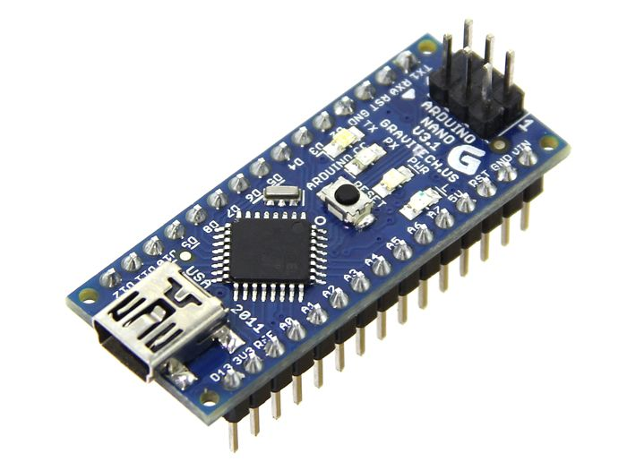**

**Figure 9. Arduino Nano**

***Source****: R*[*andomnerdtutorials*](https://randomnerdtutorials.com/)

* **Radio-frequency Identification RFID :**

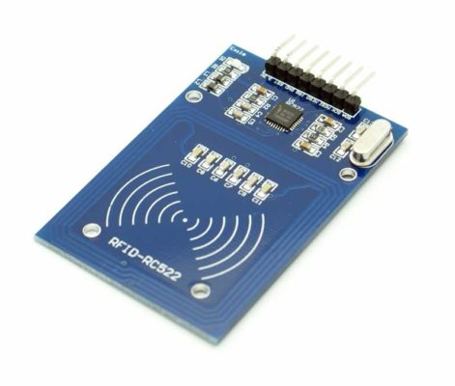Is a non-contact, automatic identification technology that uses radio signals to identify, track, sort and detect a variety of objects including people, vehicles, goods and assets without the need for direct contact or line-of-sight contact (as found necessary in bar code technology).

**Figure 10. Radio-frequency Identification**

***Source****: R[andomnerdtutorials](https://randomnerdtutorials.com/)*

**Tags (Smart Card)**

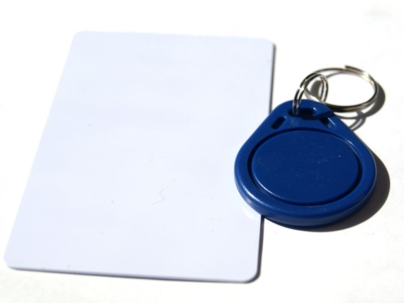RFID tags contain at least three parts: an [integrated circuit](https://en.wikipedia.org/wiki/Integrated_circuit" \o "Integrated circuit) that stores and processes information and that [modulates](https://en.wikipedia.org/wiki/Modulation" \o "Modulation) and [demodulates](https://en.wikipedia.org/wiki/Demodulation" \o "Demodulation) [radio-frequency](https://en.wikipedia.org/wiki/Radio-frequency" \o "Radio-frequency) (RF) signals; a means of collecting DC power from the incident reader signal; and an [antenna](https://en.wikipedia.org/wiki/Antenna_(radio)" \o "Antenna (radio)) for receiving and transmitting the signal. The tag information is stored in a non-volatile memory. The RFID tag includes either fixed or programmable logic for processing the transmission and sensor data, respectively.

**Figure 11. Tags (Smart Card)**

***Source****: R*[*andomnerdtutorials*](https://randomnerdtutorials.com/)

* **LCD**

An LCD is an electronic display module which uses liquid crystal to produce a visible image. The 16×2 LCD display is a very basic module commonly used in [DIYs](https://electronicsforu.com/category/electronics-projects/hardware-diy" \t "_blank) and circuits. The 16×2 translates 0 a display 16 characters per line in 2 such lines. In this LCD each character is displayed in a 5×7 pixel matrix.

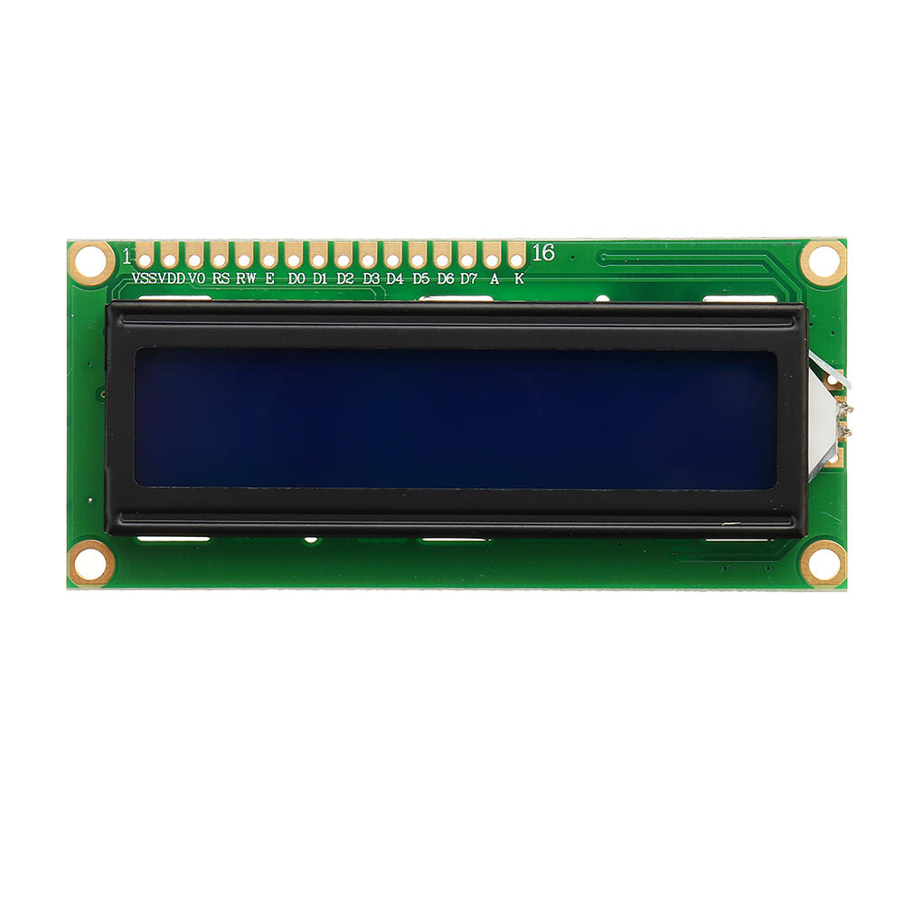

**Figure 12. LCD**

***Source*** *: R*[*andomnerdtutorials*](https://randomnerdtutorials.com/)

* **LEDs**

RGB [LED](https://www.lighting.philips.com/main/education/lighting-academy/lighting-academy-browser/video/LEDs) means red, blue and green [LEDs](https://www.lighting.philips.com/main/education/lighting-academy/lighting-academy-browser/video/LEDs). RGB [LED](https://www.lighting.philips.com/main/education/lighting-academy/lighting-academy-browser/video/LEDs) products combine these three colors to produce over 16 million hues of light. Note that not all colors are possible. Some colors are “outside” the triangle formed by the RGB [LEDs](https://www.lighting.philips.com/main/education/lighting-academy/lighting-academy-browser/video/LEDs). Also, pigment colors such as brown or pink are difficult, or impossible, to achieve.

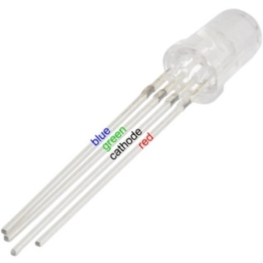

**Figure 13. LED**

***Source****: [lighting-philips](https://www.lighting.philips.com/main/support/support/faqs/white-light-and-colour/what-does-rgb-led-mean)*

**4.2 Desktop Application**

The Desktop Application is used in this Campus Access Control system to manage the use of it’s by registering the users (security agents). This system will have a super user or an admin, who will register all users of the system, and these ones will be able to manage campus the access control by allowing or denying the access to unauthorized people shown by the system itself.

**Figure 14. Login interface of the information system**

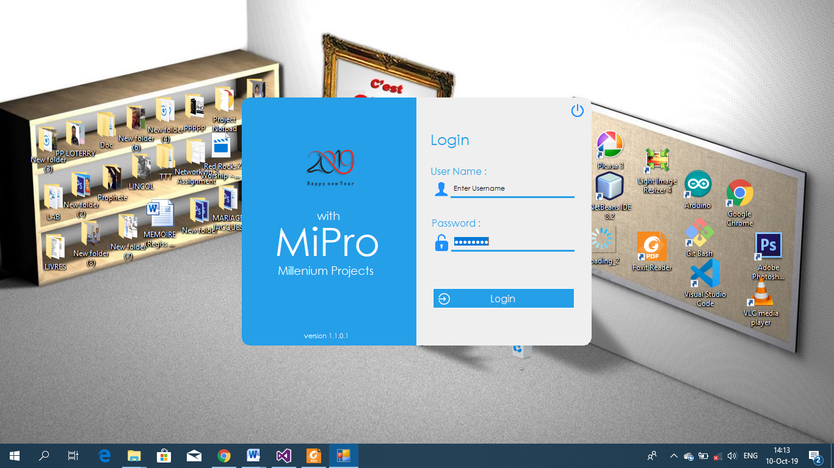

***Source****: Own drawing*

This interface it is the first interface to appear once the system is lunched and it provide the login  
interface where users can login into the system. If the user logged is an admin, he or she will be redirected the admin dashboard, where he or she can create, edit, delete a user of the system. Else, as a simple user, he or she will be redirected to the user dashboard, where he or she can manage registered student or visitors, everyone has its own dashboard different to another according to what you are representing into the system.

**Figure 15.Admin Home Page Interface**

***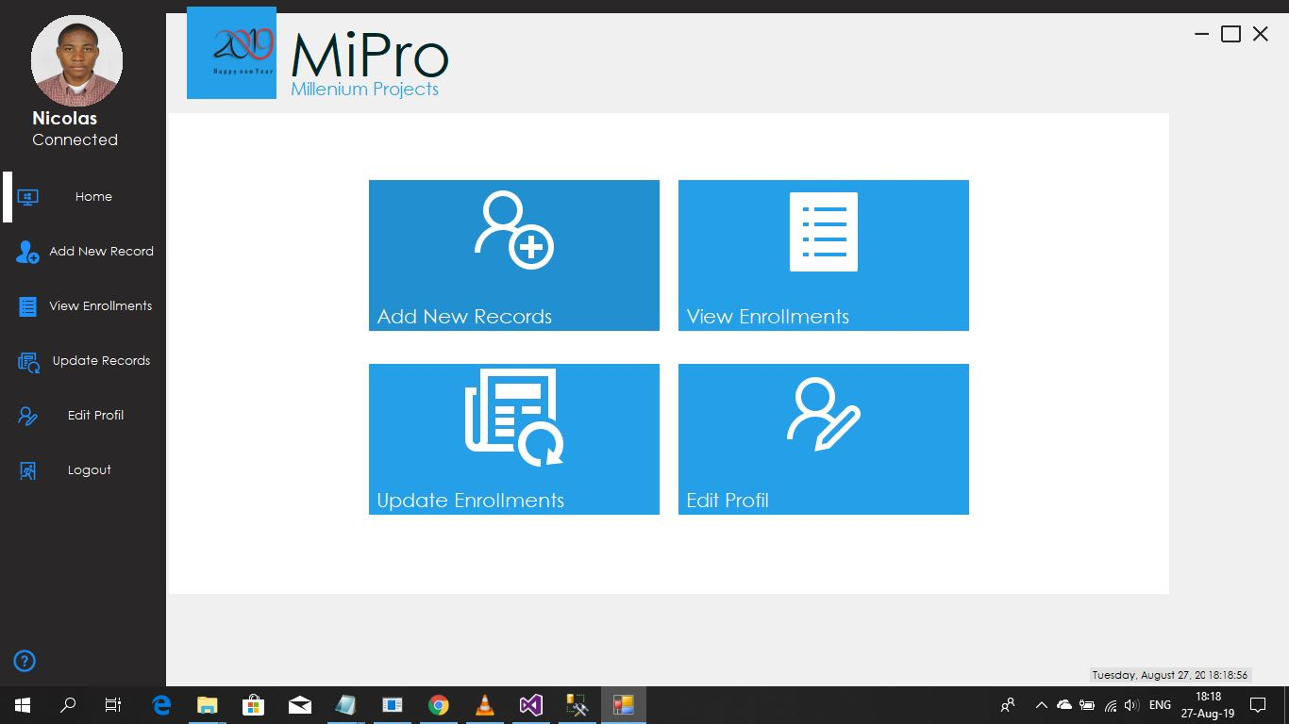***

***Source****: Own drawing*

Once the Admin is successfully logged into the system, he or she can see this dashboard where he or she can access the pages where he can:

* Add a new user or Student;
* View all users of the system;
* Update the user’s or student’s information;
* Edit his or her own profile;
* And logout the system.

DETAILS ABOUT ADMIN ENDPOINTS

* Add a new user admin should be able to add new student into the system or database information about him also his card which contain his own ID ;
* View all users of the system, Admin should be able to view all student into the database for more information about students;
* Update the user’s or student’s information, Admin should be able to edit student details;
* Edit his or her own profile, Admin should be able to edit his(her) profile;
* Logout the system, Admin should be able to sign-out from the system.

**Figure 16. Admin - Add New User Page / User**

***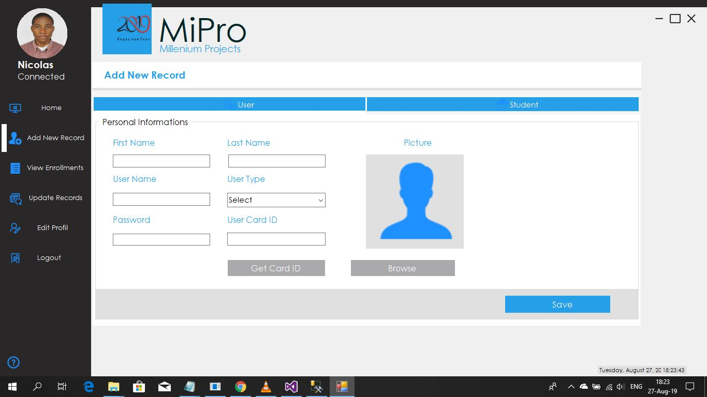***

**Source**: Own drawing.

Once the Admin is successfully logged into the system, by a simple click on the “***button Add New Records”*** he is redirected to this interface where he or she can record the information of a new user.

These are information that can be recorded:

1. First name;
2. Last name;
3. Username;
4. User type (admin/simple user);
5. Default password that will be updated by the user himself when he will get logged;
6. User Card Id that is generated by the RFID when clicking the button “***Get Card ID***” ;
7. And the user Picture chosen with a click on “***Browse***” button. Once all information are fill,

Now the Admin can click the button “***Save***” to save the information in the database.

**Figure 17.Admin - Add New Student Page / Student**

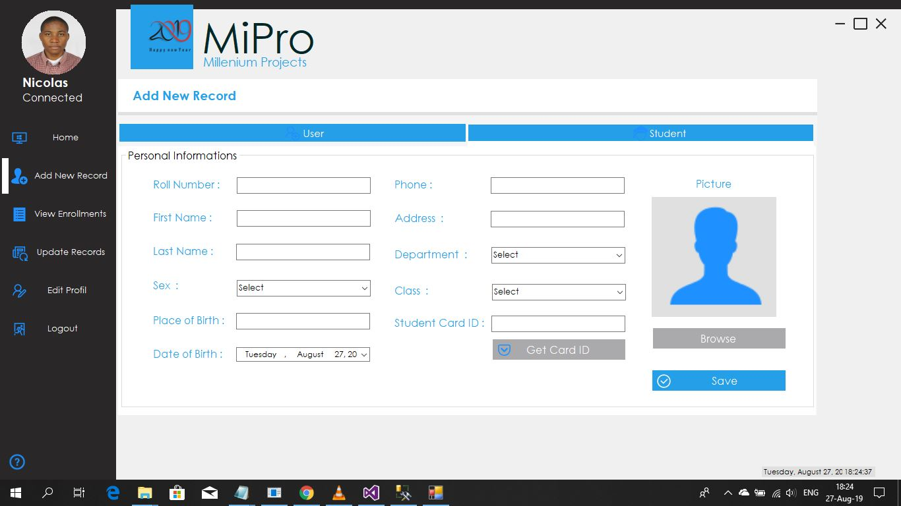

***Source****: Own drawing*

Once the Admin is successfully logged into the system, by a simple click on the “***button Add New Records”*** and then “***Student***” he is redirected to this interface where he or she can fill these field to record the information of a new student. Once all information is fill, now the Admin can click the button “***Save***” to save the information in the database.

ENDPOINTS:

1. Admin should be able to records new student
2. Admin should save information after reviewing

**Figure 18. Admin - View Enrollments Page / All Users**

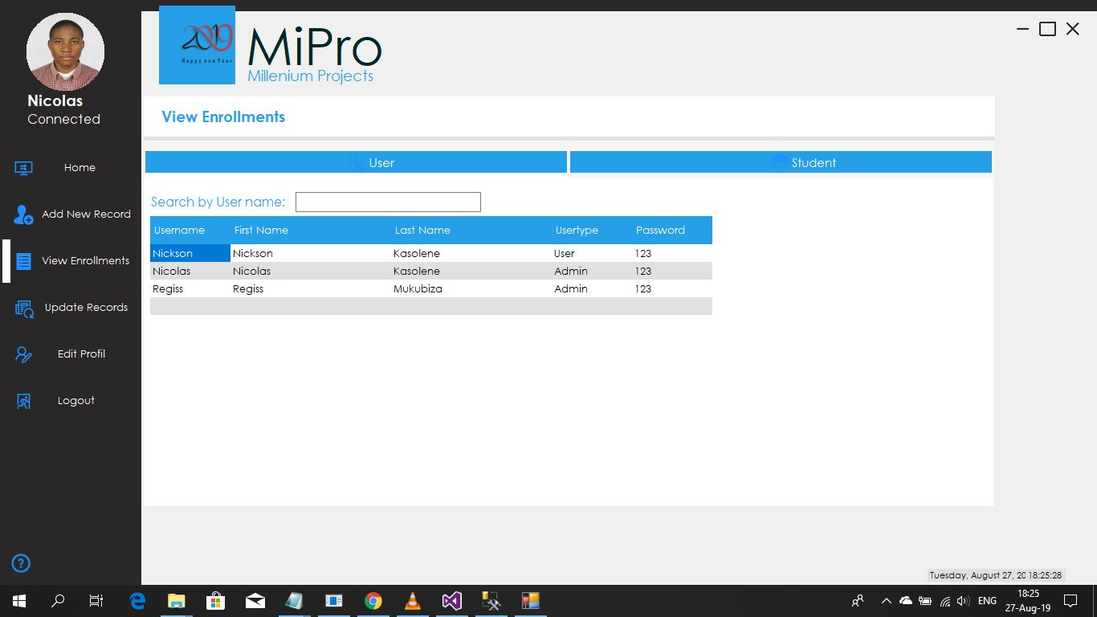

***Source****: Own drawing*

Once the Admin is successfully logged into the system, by a simple click on the “***View Enrollments”*** button he is redirected to this interface where he or she can view all users recorded in the database, and by entering the User name on the search filed he can view single user information.

ENDPOINTS:

1. Admin should view all users recorded in the database

**Figure 19. Admin - View Enrollments Page / All Students**

***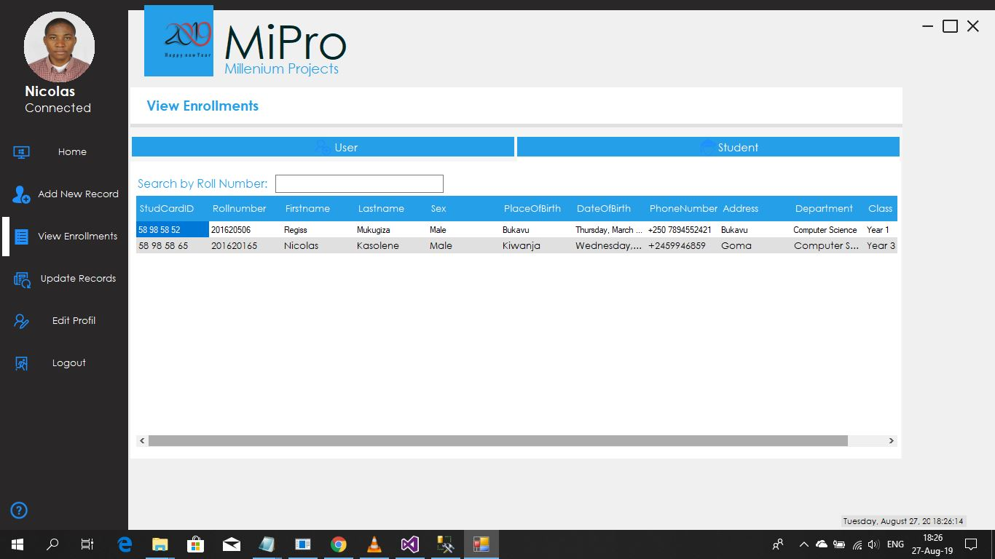***

***Source****: Own drawing*

Once the Admin is successfully logged into the system, by a simple click on the “***View Enrollments”*** and then ***“Student”*** button he is redirected to this interface where he or she can view all students recorded in the database, and by entering the student’s Roll number on the search filed he can view single student information.

ENDPOINTS:

1. Admin should be able to view all students recorded into the database

**Figure 20. Admin – Update Records Page / User**

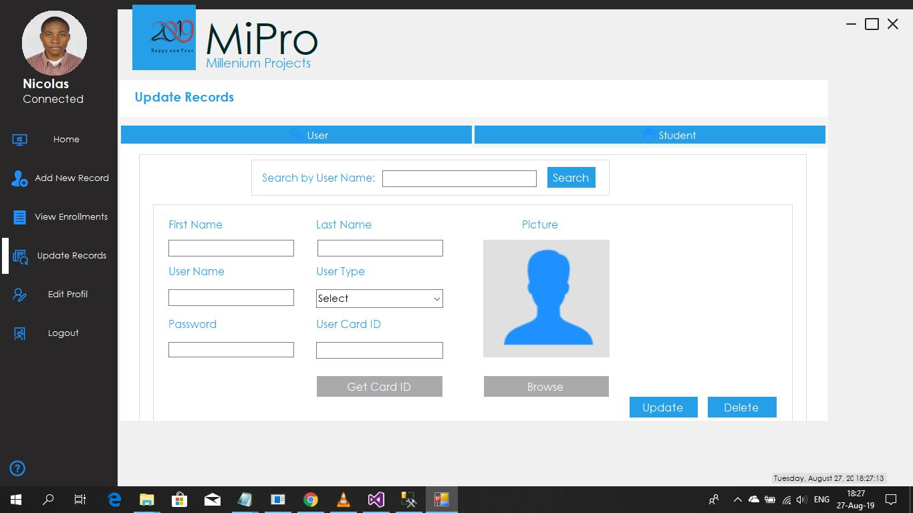

***Source****: Own drawing*

Once the Admin is successfully logged into the system, by a simple click on the “***Update Records”*** button he is redirected to this interface where he or she can update the information of a user in the database by entering the User name of the User on the search filed he can get information of that single user and then by a click on “***update***” or “***delete***” button, he can update or delete the user.

ENDPOINTS:

1. Admin should be able to update information of users
2. Admin should be able to delete users

**Figure 21. Admin – Update Records Page / Student**

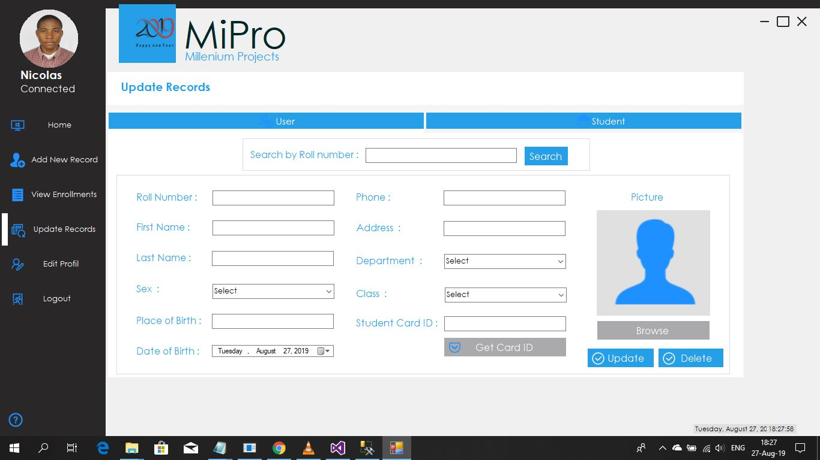

***Source****: Own drawing.*

Once the Admin is successfully logged into the system, by a simple click on the “***Update Records”*** button, and then “***Student***” he is redirected to this interface where he or she can update the information of a student in the database by entering the Roll number of the User on the search filed he can get information of that single student and then by a click on “***update***” or “***delete***” button, he can update or delete the information of the student.

ENDPOINTS:

1. Admin should be able to update information of students;
2. Admin should be able to delete students.

**Figure 22. Admin – Edit Profile**

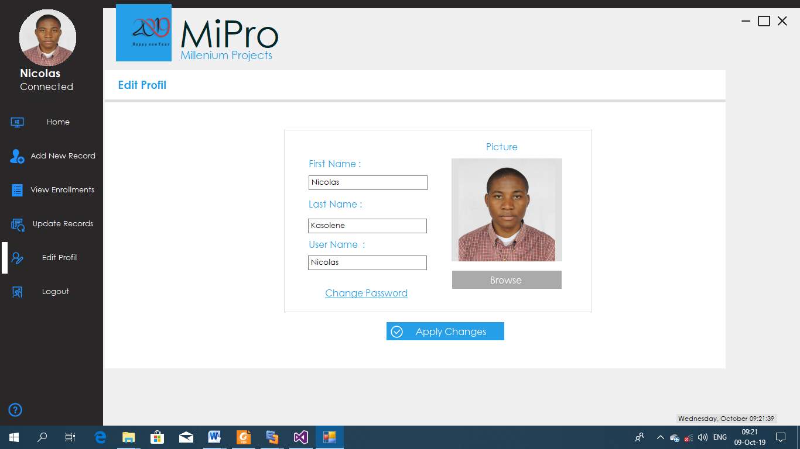

***Source****: Own drawing.*

Once the Admin is successfully logged into the system, by a simple click on the “***Edit Profile”*** button he is redirected to this interface where he or she can edit his profile, and then by a click on “***Apply Changes***” button he will get a notification that his profile is successfully edited.

ENDPOINTS:

1. Admin should be able to edit his profile and then save changes.

**Figure 23. Admin – Logout**

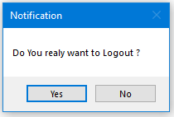

***Source****: Own drawing*

Once the Admin is successfully logged into the system, by a simple click on the “***Logout”*** button he get this notification for him to confirm either he logout or not. If “***Yes***”, then he will be redirected to the login form. And if “***No***” he will stay on the admin panel page.

ENDPOINTS:

1. Admin should be able logout.

**Figure 24. User Home Page Interface**

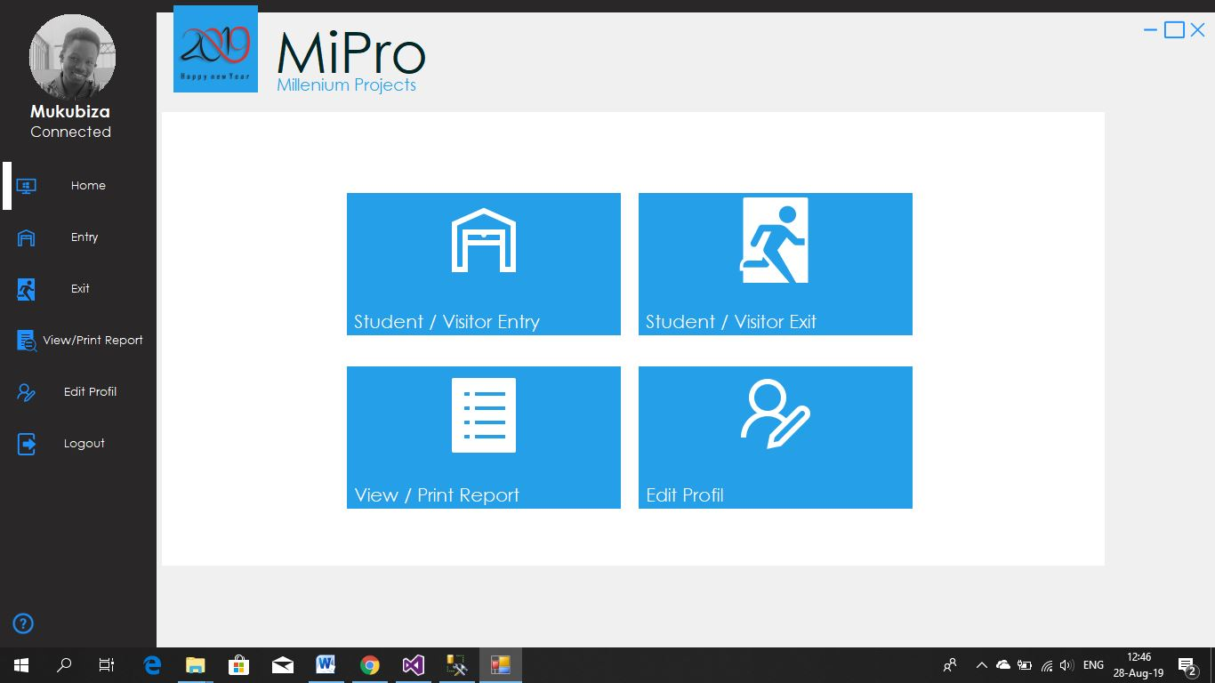

***Source****: Own drawing.*

Once a User is successfully logged into the system, he or she can see this dashboard where he or she can access the pages where he can:

1. Scan student’s smart card or record visitor’s information;
2. View all entries in the campus for both students and visitors ;
3. View all exits from the campus for both students and visitors;
4. View or Print the reports;
5. Edit his or her own profile;
6. And log out the system.

**Figure 25. User - Entry Page / Students**

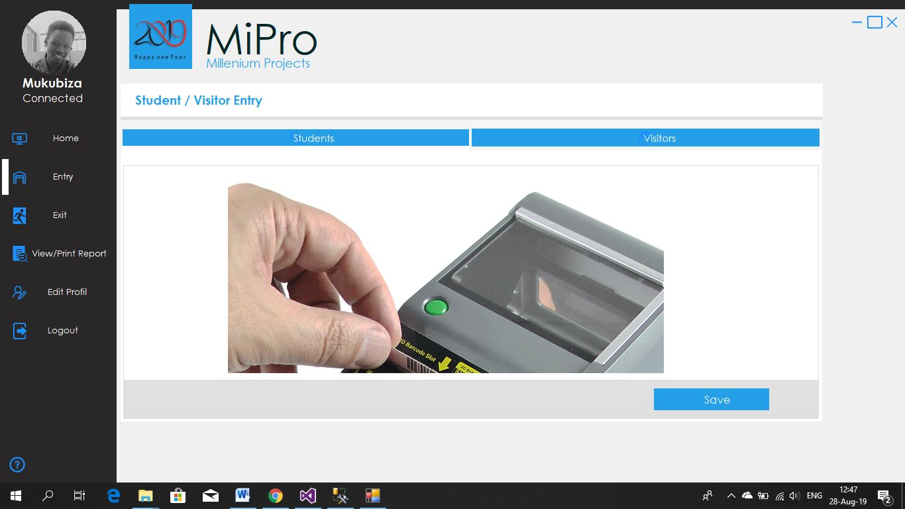

***Source****: Own drawing.*

Once the User is successfully logged into the system, by a simple click on the “***Entry”*** he is redirected to this interface where he or she can manage the entry information of a student. This scenario goes like this, student is required to insert his or her student card (smart card) into the RFID Card Reader, this one will check pass the ID into the application’s database to check if the student exist in the database. If yes, the student will be allowed to pass and get into the campus; otherwise the student will not be allowed.

ENDPOINTS:

1. User should have his own ID through its card;
2. Student should have his own ID through its card.

**Figure 26. User - Entry Page / Visitors**

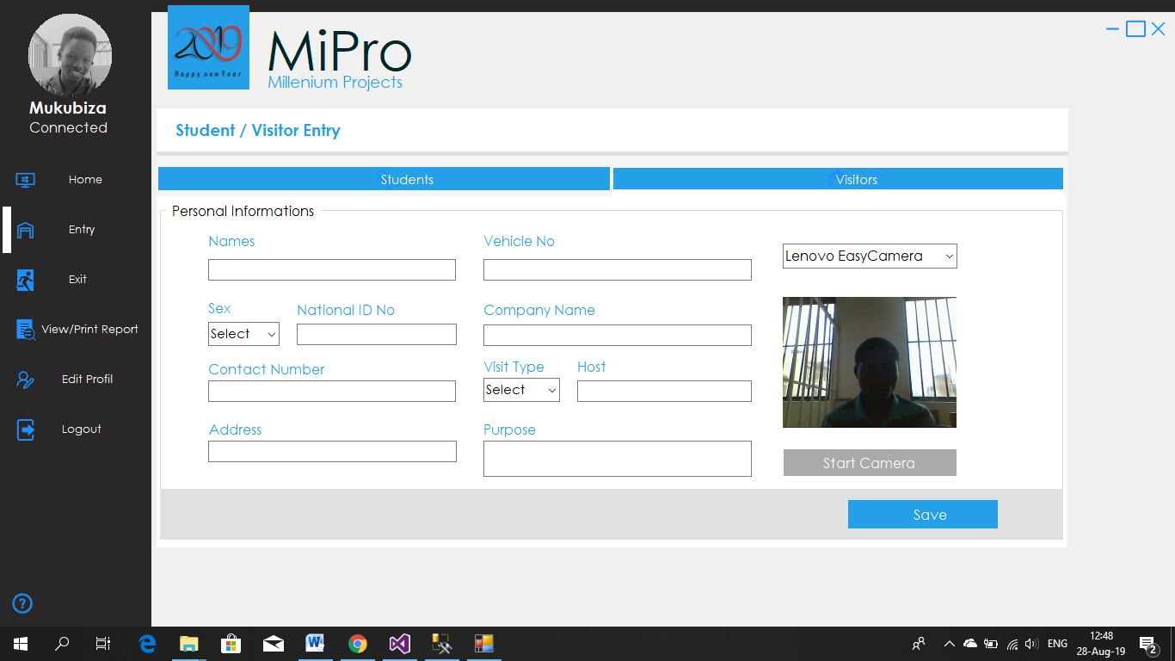

Source: Own drawing

Once the User is successfully logged into the system, by a simple click on the “***Entry”*** end the “**Visitors**”he is redirected to this interface where he or she can record the entry information of a visitor. As the visitor does not have a student card but want to get into the campus, he has to give his National ID to the Security (User of the system) and provide him or her with other information that are not at the National ID. For the purpose of security, the photo of the visitor is also taken via a USB Camera plugged to the machine just by a click on “***Start Camera***” and after “***Capture***”. Once all required information are full, the user can save the into the database by a click on “***Save***”.

ENDPOINTS:

1. User should be able to record information;
2. User should be able to scan the card;
3. User should be able to record his profile’s picture through webcam (camera).

**Figure 27. User - Exit Page / Students**

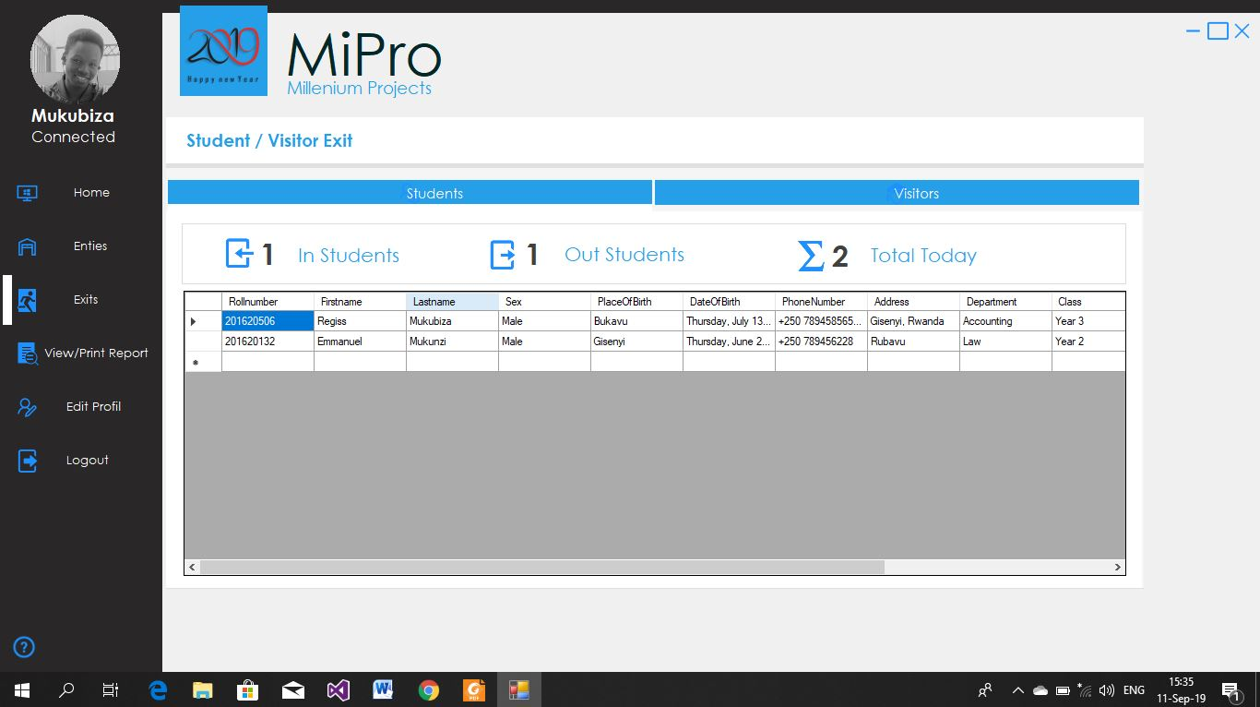

Source: Own drawing

Once the User is successfully logged into the system, by a simple click on the “***Exit”*** he will be redirected to this interface where he or she can view the number of students in the campus and the number of students that exit the campus.

ENDPOINTS:

1. User should be able to see all students in the campus;
2. User should be able to see all students out the campus.

**Figure 28. User - Exit Page / Visitors**

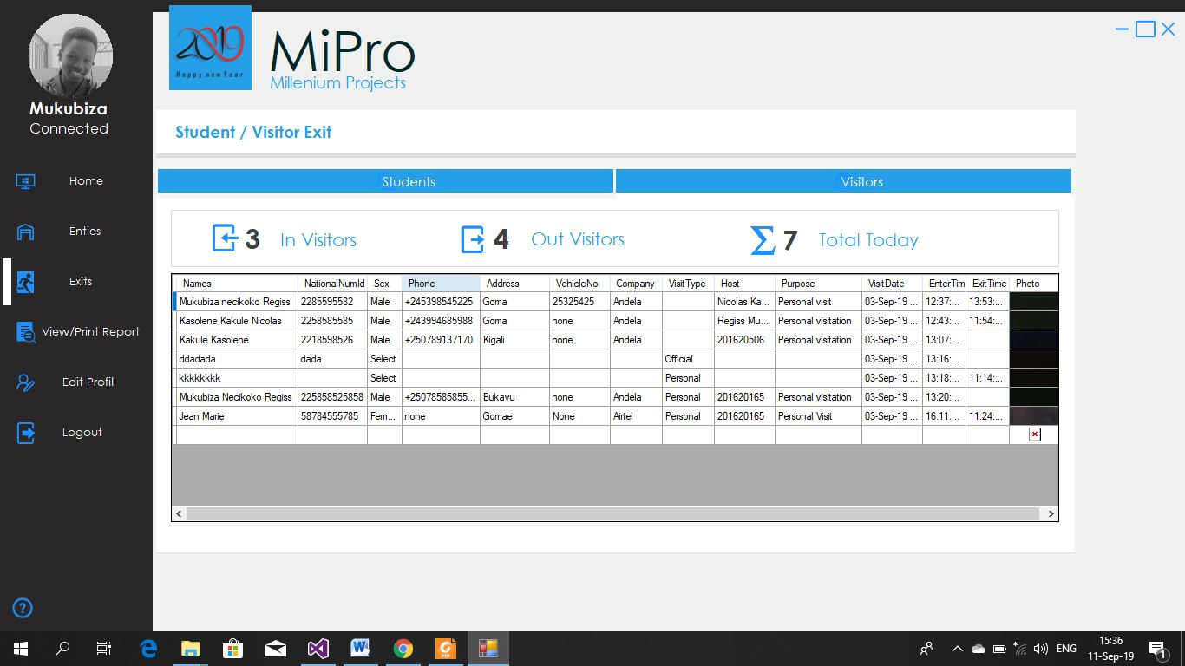

Source: Own drawing

Once the User is successfully logged into the system, by a simple click on the “***Exit”*** and then “***Visitors***” he will be redirected to this interface where he or she can view the number of visitors in the campus and the number of visitors that exit the campus.

ENDPOINTS:

1. User should be able to view all visitors in the campus;
2. User should be able to view all visitors out the campus;

**Figure 29. User - View / Print Page / Students**

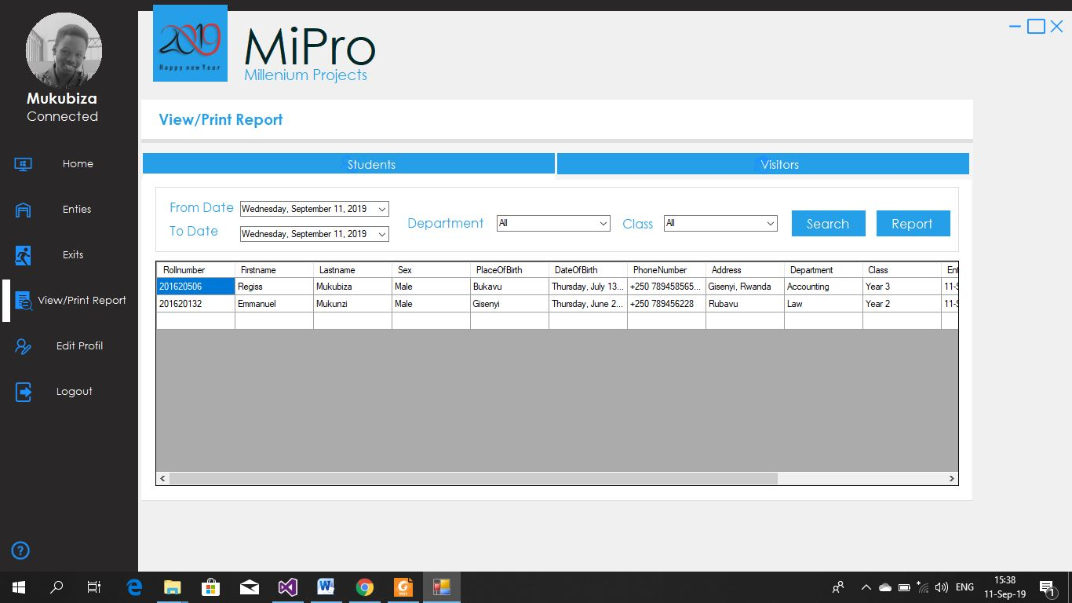

Source: Own drawing

Once the User is successfully logged into the system, by a simple click on the “***View / Print Report”*** he will be redirected to this interface where he or she can view or print all entries filtering them by date, department and class.

ENDPOINTS:

1. User should be able to view print all student’s reports

**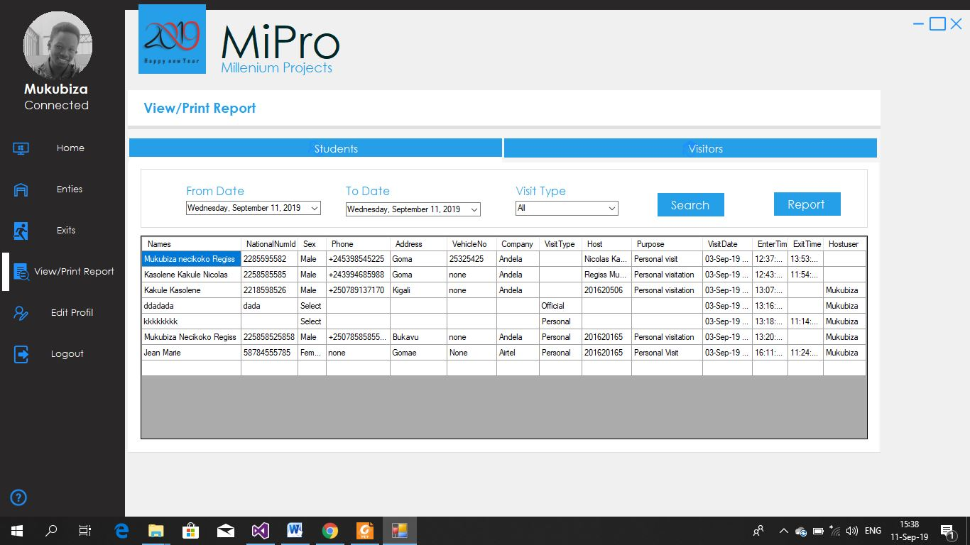Figure 30.User - View / Print Page / Visitors**

Source: Own drawing

Once the User is successfully logged into the system, by a simple click on the “***Exit”*** and then “***Visitors***” he will be redirected to this interface where he or she can view or print all entries filtering them by date, company, visit type and host.

ENDPOINTS:

1. User should be able to print all visitors’ report.

**Figure 31.User – Edit Profile**

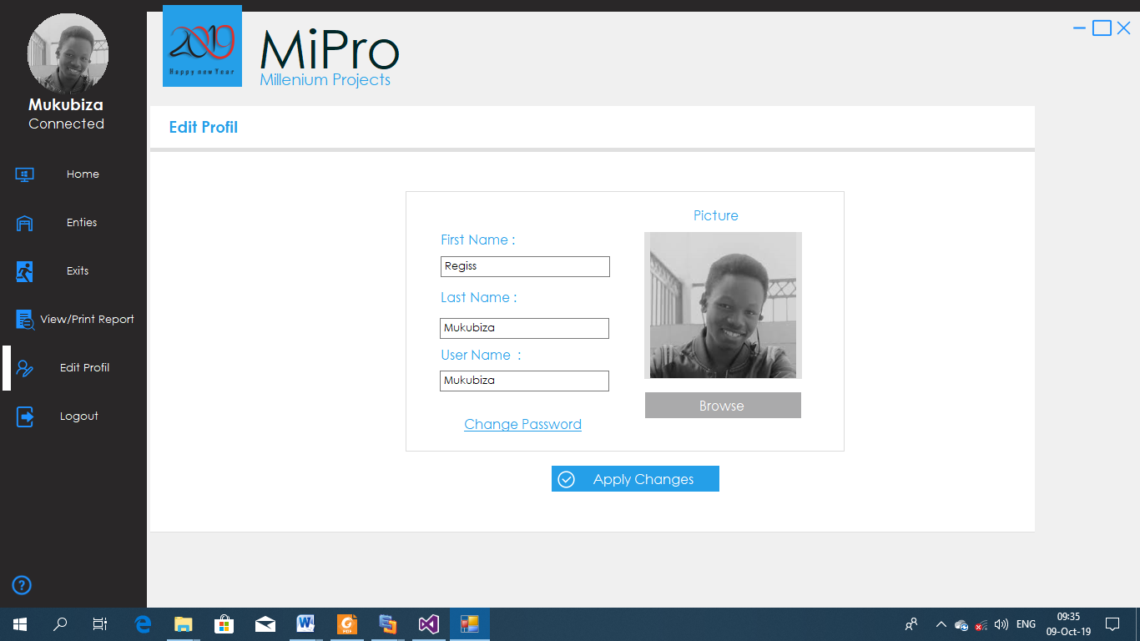

**Source**: Own drawing.

Once the Admin is successfully logged into the system, by a simple click on the “***Edit Profile”*** button he is redirected to this interface where he or she can edit his profile, and then by a click on “***Apply Changes***” button he will get a notification that his profile is successfully edited.

ENDPOINTS:

1. User should be able to change his profile.

**Figure 32. Admin – Logout**

****

***Source****: Own drawing.*

Once the Admin is successfully logged into the system, by a simple click on the “***Logout”*** button he get this notification for him to confirm either he logout or not. If “***Yes***”, then he will be redirected to the login form. And if “***No***” he will stay on the admin panel page.

ENDPOINTS:

1. User should be able to logout.

**Figure 33. Admin / User Change Password**

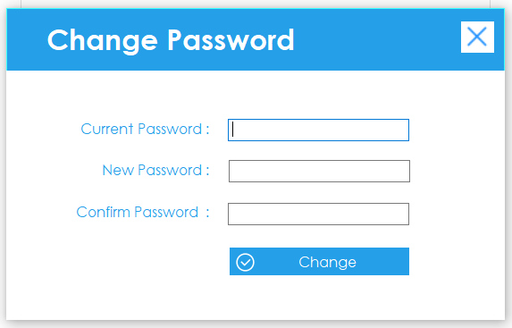

***Source****: Own drawing.*

Once the Admin or Useris successfully logged into the system, by a simple click on the “***Change Password”*** link he get this form for him to change the password by entering the current password, new password and confirm the new password.

ENDPOINTS:

1. Admin or User should be able to change the password.

# CHAPTER 5. CONCLUSION AND RECOMMANDATION

## **Conclusion**

Throughout this work it has been developed a full campus an electronic device called access control based on the smart card technology with the help of a desktop application to store the student and visitor information in the database. Within the proposed system, the Smart Card is primarily used as an identification device with a unique ID encoded onto the Smart Card.

To have the system working properly, some cheap sensors have been used along with the Arduino nano to develop RFID controller and a desktop application to store the student information and record the visitor information into the database using the unique ID from the smart student card.

The development of this project gave us important experience and more additional knowledge about RFID working principle, control, the usage of microcontrollers and electronic sensors, desktop application programming specially the establishment of the connection between electronic devices and desktop application.

At the end of this project we are really satisfied with the overall achievement and with the knowledge we got through the execution of this project.

## **Recommandation**

In the future we recommend to other researchers interested in this project to implement another version of this access control system improves this project by adding other important features by:

• Adding fingerprint to access the campus and password locker in case the RFID system fails.

We also recommend Kigali Independent University – Gisenyi Campus to use this system as it solves several previous problems of it during the access control tasks.

## **FUTURE WORK**

* The implementation of this system connected with the web application;
* Adding new features to make this system usable in other school activities, financial management, library management, attendance management, inventory management, asset tracking, personnel tracking, controlling access to restricted areas, ID badging, supply chain management, counterfeit prevention (e.g. in the pharmaceutical industries) etc.

# REFERENCES

1. TURABIAN, K.L., (1982), *a manual for writers of research paper. Theses and Dissertations*. London.
2. HUMBLET, J.E. (1980), *How to get documentation, Paris.*
3. ADAMS, G.R., & SCHVANNELDT, J.D. (1985) *Understanding Research Methods,* New York: Longman.
4. RAYMOND Q. ET CAMPENHOUD, (1995), M*anuel de recherche en sciences sociales,* éd. Dunod, Paris.
5. GRAWITZ. M: (1982), Social sciences methods, Dalloz. Paris.
6. S Goldthwaite, W Graylin.(2004) contactless smart card Retreived on (August 21, 2019) from the World Wide Web:  <https://scholar.google.com/scholar?hl=en&as_sdt=0%2C5&q=contactless+smart+card&btnG=>;
7. [Sanjay Sarma](https://dl.acm.org/author_page.cfm?id=81100143732&coll=DL&dl=ACM&trk=0) . OAT Systems and MIT, American Barcode and RFID Queue - RFID [Queue Homepage](http://queue.acm.org/) [table of contents](https://dl.acm.org/citation.cfm?id=1035594&picked=prox) [archive](https://dl.acm.org/citation.cfm?id=J882&picked=prox). Retrieved from (October 25, 2019) the World Wide Web: <https://dl.acm.org/citation.cfm?id=1035620>;
8. Bruce, James. (2011). *What Is Arduino & What Can You Do With It?.* Retrieved on (August 20, 2018) from the World Wide Web: https://www.makeuseof.com/tag/arduino-technology-explained;
9. [Margaret Rouse](https://www.techtarget.com/contributor/Margaret-Rouse).(2014).*Smart Card*. Retrieved on (August 20, 2019) from the World Wide Web:  <https://searchsecurity.techtarget.com/definition/smart-card>
10. AB&R® American Barcode and RFID. (2004). What is RFID reader? Retrieved on (August 21, 2019) from the World Wide Web: <https://www.abr.com/solutions/rfid/>);
11. Techopedia. What is a software. Retrieved on (August 22, 2019) from the World Wide Web: <https://www.techopedia.com/definition/4224/application-software>*;*
12. *Pcmag. What is desktop software?* Retrieved on (*August 22, 2019*) *from* the World Wide Web: [*https://www.pcmag.com/encyclopedia/term/41158/desktop-application*](https://www.pcmag.com/encyclopedia/term/41158/desktop-application)*;*
13. [Alina Bradford](https://www.livescience.com/author/alina-bradford)*. (2017).* What Is a Scientific Hypothesis?*Retrieved on (August 22, 2019) from* the World Wide Web: <https://www.livescience.com/21490-what-is-a-scientific-hypothesis-definition-of-hypothesis.html>*;*
14. SK Kim, C David. (1999). What is a class diagram, Retrieved on (August 22, 2019) from the World Wide Web: <https://scholar.google.com/scholar?hl=en&as_sdt=0%2C5&q=class+diagram&btnG=>;
15. Margaret Rouse. (2014, January 8). [searchmicroservices.techtarget.com](http://searchmicroservices.techtarget.com/). Retrieved on (August 28, 2019) from the World Wide Web: <https://searchmicroservices.techtarget.com/definition/software>;
16. David Mal (Wikipedia). (September 16, 2018). Database. Retrieved on (August 19, 2019) from the World Wide Web: <https://en.wikipedia.org/wiki/Database>;
17. Fernando. (2017, February 19). Waterfall Model. Retrieved on (July 23, 2019 ) from the World Wide Web: <http://toolsqa.com/software-testing/waterfall-model/>;
18. Julius Guzer. (2015). [www.techopedia.com](http://www.techopedia.com/). Systems Requirement. Retrieved on (August 17, 2019) from the World Wide Web:<https://www.techopedia.com/definition/4371/system-requirements>;